# Lesson 2: Working with Scientific Notation and Units

## Essential Questions

How does scientific notation simplify the representation of extremely large and small numbers in science?

## Big Idea

Mastering scientific notation and consistent units is key for clear communication and accurate results in scientific work.

## Lesson Phenomenon

The forensic chemist conducted several measurements of the bracelet. For example, its mass and volume were measured. The assistant chemist was asked to report the finding to the insurance company. The assistant obliged and informed that the values of 40,000 and 2.07. The insurance company could not make sense out of those numbers. Was the mass 40,000 grams? 4000 milligrams? 2.07 kilograms? Was the volume 40,000 cubic millimeters? Without units, a measurement was meaningless.

The forensic chemist also measured the width of several diamond facets found it the bracelet. A diamond facet is a precisely cut and polished surface that reflects and refracts light, contributing to the diamond's brilliance and sparkle. The width and angles of a diamond's facets significantly influence its value. The width of a facet can vary significantly depending on the diamond's cut, shape, and size. The forensic chemist measured some facet width to be 0.00003 meters while others were 0.000025 meters. Which measurement is bigger? Which one is smaller? It is hard to compare when presented this way with tons of 0’s in decimal places.

## Vocabulary

Base Units

Dimensional Analysis

Meter

Kilogram

Scientific notation

Second

SI Units

Ampere

Candela

Kelvin

## Lesson Objectives

By the end of the lesson, I will be able to:

• Express numbers in scientific notation.

• Perform dimensional analysis to convert units.

• Develop a method to convert between different units using dimensional analysis.

## <H1>Direct instruction: How can the bracelet’s metal be identified?

Substances can be identified by their properties. Density is a physical property of matter that is useful to determine whether a substance is what it seems to be. Since different substances have different densities, if the density of an object coincides with the density of a substance, then chances are the object is made out of that substance.

As you learned in earlier grades, density is defined as the mass of an object per unit volume; it measures how tightly packed the matter is in a given space. For example, gold is denser than silver, which is denser than water. Identifying substances by their density is a technique particularly useful in fields like materials science, where accurate identification of substances is crucial.

<H1> Pathfinder: Density lab (Quick lab)

Objective: To learn how to measure the density of liquids and solids

Materials and Equipment

* A digital balance
* Small beakers or weighing dishes
* Water
* A solid object that can be submerged in water and stay unaltered (for example a small plastic toy or a glass marble)

Procedure

1. Work with a partner to identify what measurements you need to take to calculate density (Hint: find the formula for density)
2. Design a way to conduct those measurements for a liquid and for a solid using the materials and equipment in the Materials and Equipment list.
3. Conduct repeated measurements to ensure accuracy and precision; record the data and calculate the density for the liquid and the solid.
4. Report your results with the correct number of significant figures and using the correct units.
5. Compared your findings to the densities of oil, saltwater, glass, and plastic. Were you able to identify the solid and liquid objects?

## <H1>Lightbulb: Units and the SI

The forensic chemist wanted to report the value for the density of gold according to international standards. The International System of Units is the metric system developed in France during the late 18th century, that’s why it is called the SI (for its French’s abbreviation S*ystème International*). It is a set of standardized units used across the world to ensure consistency in measurements. The SI is the metric system. It is made up of 7 base units, which are:

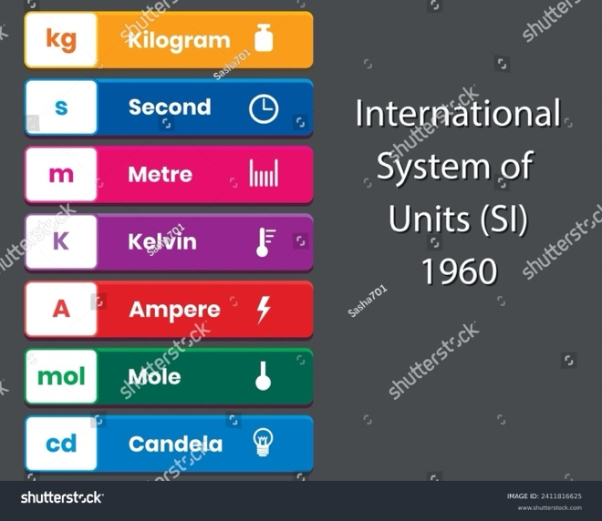

Kilogram (kg) is the unit for mass, second is the unit for time, meter is the unit for length, kelvin is the unit for temperature, Ampere is the unit for electric current, mole is the unit for amount of substance, and candela is the unit for luminous intensity.

These 7 units are used for defining derived units, which are formed by different operations on the 7 base units. For example Newton (N) is the unit of force and is equivalent to kg・m/s2.

Furthermore, the SI units can also be expressed as standard multiple or as fractional quantities in powers of 10 and defined with the use of prefix multipliers. For example, a thousandth of a meter is a *milli*meter which is 0.001 m.

## Progress Check 1

1. What would be the units for area or volume in SI?

2. What would be the units for density in SI?

You probably notice that there are no units of capacity in the 7 base units of the SI. Capacity is measured in units of liters (l). How is a liter defined? One liter was defined as a cubic decimeter. That is, a liter is the capacity that a cube of 1 decimeter by 1 decimeter by 1 decimeter can hold.

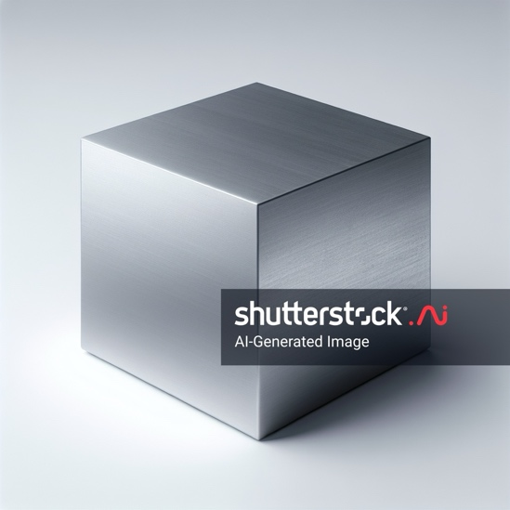

## Progress Check 2

1. What would be the size of the cube that holds 1 milliliter?
2. Write an equation to show the equivalence between milliliters and cubic centimeters.

## <H1>Lightbulb: Dimensional Analysis and Unit Conversion

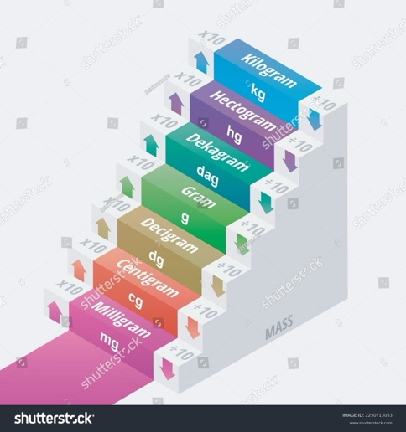The chemist measured the mass of the metal in the bracelet to be 40,000 mg and the volume 2.07 cubic centimeters but the values need to be expressed in SI so some unit conversion needs to take place. Dimensional analysis is a tool to convert between different units using conversion factors. For units of length and mass, those factors are powers of 10.

To convert kilograms to grams, you need to multiply by 10 several times; you multiply by 10 because you go down the ladder, to smaller units.

7 kg = 7 × 10 hg = 7 × 10 × 10 dag = 7 × 10 × 10 × 10 g

7 kg = 7 × 1000 g =. 7000 g

The conversion factor is 1000.

If you need to convert centimeters to meters, then you need to go up the ladder, to larger units. Then, instead of multiplying by 10 you have to divide by 10. For instance, to convert 25 centimeters to meters:

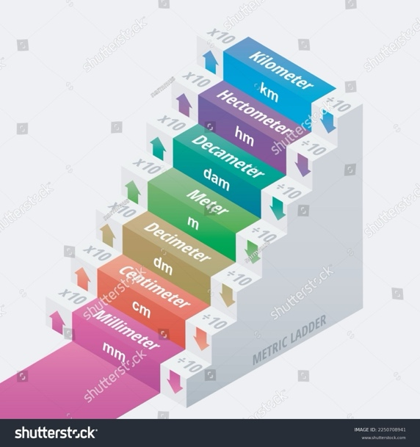

25 cm = 25 ÷ 10 dm = 25 ÷ 10 ÷ 10 m = 25 ÷ 100 m

25 cm = 25 ÷ 100 m = 25 ÷ 102 m = 0.25 m

The conversion factor is always a factor, that means that it should be expressed as a multiplication. Recall the rules of powers from previous grades math; to change the division to a multiplication we can change the sign of the power.

25 cm = 25 × 10-2 m

The conversion factor is 10-2

## Progress Check 3

1. How would you convert 452 g into units of kilograms? What is the conversion factor?
2. How would you convert 0.624 m into units of mm? What is the conversion factor?
3. Calculate the density of the metal in the bracelet and express it as kg/m3 and as kg/l.

Converting units other than length or mass is performed in the same way but the conversion factor may not be powers of 10. For example, to convert hours to minutes and from minutes to seconds you have to multiply 60 each time. For example,

9 h = 9 × 60 min = 9 × 60 × 60 s = 9 × 3600 = 32,400 s

The conversion factor from h to s is 3600.

7200 s = 7200 ÷ 60 min = 7200 ÷ 60 ÷ 60 h = 7200 × 0.000278 = 2 h

The conversion factor from s to h is 0.000278.

Some countries (the United States, Liberia, and Myanmar) use miles instead of km to measure large distances. The conversion factor is approximately 1.6 to go from miles to km. For example:

8.4 miles = 8.4 × 1.6 km = 13.44 km

## <H1> Lightbulb: Scientific Notation

The forensic chemist also measured the width of several diamond facets found it the bracelet and found that some were 0.000003 meters in width while others were 0.000025 meters. How could these measurements be easily compared?

We can use dimensional analysis and try to express the numbers with just one integer followed by decimals. For example:

0.000003 m = 3 × 0.000001 m = 3 × 10-6 m

0.000025 m = 2.5 × 0.00001 m = 2.5 × 10-5 m

It is now easy to see that 2.5 × 10-5 is larger than 3 × 10-6

Scientific notation is used also for large numbers. For example, the distance between Earth and the Sun is 149,600,000,000 km. How is this number expressed using scientific notation?

Always with one integer (followed by decimals if needed).

149,600,000,000 km = 1.496 × 1011 km

In some books, you will find that the Earth-Sun distance is 1.5 × 1011 km. Is this value wrong? Of course not, recall significant figures from the previous lesson. The value 1.496 × 1011 is expressed with 4 significant figures whereas the value of 1.5 × 1011 is expressed with 2 significant figures.

## Progress Check 4

1. Use dimensional analysis to express the Earth-Sun distance in meters?
2. The mass of Earth is about 59,722,000,000,000,000,000,000,000,000 kg. Express this value in scientific notation with 3 significant figures.
3. The mass of a single gold atom is approximately 0.000000000000000000000000327 kg. Express this value in scientific notation with 2 significant figures.

## Power Up: Questioneer Icon

Reflect on the following prompts to think critically about the content and come up with meaningful questions for inquiry about scientific notation and units.

* Different units can represent the same quantity.
* Unit conversions are essential for comparisons of measurements.
* Understanding significant figures is important when using scientific notation.

## 

## **Evaluate: Lesson Check**

1. Why is it important to express measurements with units? How would misusing units affect interpretation?
2. Convert the value of 4,500 km to scientific notation in m.
3. Which of the following represents the correct conversion of 0.0035 kilograms into grams, expressed in scientific notation?
$3.5× {10}^{1} grams$

$3.5× {10}^{\left\{2\right\}}grams$

$3.5×{10}^{\left\{3\right\}} grams$

$3.5× {10}^{\left\{4\right\}}grams$

5. Express the densities of the solid and the liquid you calculated in kg/l and g/ml
6. Design a scenario where you would need to convert units (e.g., from meters to kilometers) and apply scientific notation to express your answer. What steps would you take?

## Extend: Beyond the Lesson

Scientific notation and unit conversion are not only essential in the lab but play a vital role in many aspects of our daily lives. These concepts simplify calculations involving extremely large or small numbers, which we encounter in fields such as astronomy, engineering, and finance. For example, when discussing the vast distances between planets or the minute measurements in nanotechnology, scientific notation makes these numbers easier to manage and understand. In finance, it helps simplify large transactions or population statistics.

Unit conversion is equally important in areas such as travel, where converting between miles and kilometers is crucial, or in cooking, where recipes might require switching between grams, ounces, or cups. Understanding how to accurately convert units helps ensure consistency, whether you're following a recipe or determining the correct dosage of medicine.

In the context of sustainability and environmental awareness, converting energy usage data or carbon footprints from different units allows individuals and organizations to measure their impact on the environment more clearly. Mastering scientific notation and unit conversion empowers people to make informed decisions in both everyday tasks and critical global issues, contributing to a better understanding of the world.